A

Real-Time Research Project On

## PARALYSIS PATIENT ALERTING AND MONITORING SYSTEM

(Submitted in partial fulfillment of the requirements for the award of Degree)

### BACHELOR OF TECHNOLOGY

In

### COMPUTER SCIENCE AND ENGINEERING

By

M.Aravind (237R1A05N6)

A.Kalyani (237R1A05K8)

N.Naveen (237R1A05P5)

P.Manusree (247R1A0522)

Under the Guidance of

#### Dr. Mantesh Patil

(Associate Professor)



**DEPARTMENT OF COMPUTER SCIENCE AND ENGINEERING**

**CMR TECHNICAL CAMPUS**

**UGC AUTONOMOUS**

(Accredited by NAAC, NBA, Permanently Affiliated to JNTUH, Approved by AICTE, New Delhi)

Recognized Under Section 2(f) & 12(B) of the UGCAct.1956, Kandlakoya (V), Medchal Road, Hyderabad-501401.

**April, 2025.**

**DEPARTMENT OF COMPUTER SCIENCE AND ENGINEERING**



## CERTIFICATE

## This is to certify that the project entitled Paralysis Patient Alerting And Monitoring System being submitted by M.Aravind (237R1A05N6), A.Kalyani (237R1A05K8), N.Naveen (237R1A05P5) & P.Manusree (247R1A0522) in partial fulfillment of the requirements for the award of the degree of B.Tech in Computer Science and Engineering to the Jawaharlal Nehru Technological University Hyderabad, during the year 2024-25.

The results embodied in this thesis have not been submitted to any other University or Institute for the award of any degree or diploma.

**Dr. Mantesh Patil Dr. Nuthanakanti Bhaskar Associate Professor HOD**

**INTERNAL GUIDE**

## ACKNOWLEDGEMENT

We take this opportunity to express our gratitude to the people who have been instrumental in the successful completion of this project, we take this opportunity to express our profound gratitude and deep regard to our guide **Dr. Mantesh Patil,** Associate Professor for his exemplary guidance, monitoring and constant encouragement throughout the project work. The blessing, help and guidance given by him shall carry us a long way in the journey of life on which we are about to embark.

We take this opportunity to extend our heartfelt appreciation to the Project Review Committee (PRC) Coordinators—**Dr. Mantesh Patil, Mrs. G. Swathi, and Mrs. Niharika**—for their unwavering support, insightful guidance, and valuable inputs, which played a crucial role in steering this project through its various stages.

Our sincere appreciation also goes to **Dr. Nuthanakanti Bhaskar**, Head, for his encouragement and continuous support in ensuring the successful completion of our project.

We are deeply grateful to **Dr. A. Raji Reddy**, Director, for his cooperation throughout the course of this project. Additionally, we extend our profound gratitude to Sri. **Ch. Gopal Reddy**, Chairman, Smt. **C. Vasantha Latha**, Secretary and Sri. **C. Abhinav Reddy**, Vice-Chairman, for fostering an excellent infrastructure and a conducive learning environment that greatly contributed to our progress.

We also acknowledge and appreciate the guidance and assistance provided by the faculty and staff of **CMR Technical Campus**, whose contributions have been invaluable in bringing this project to fruition.

Lastly, we sincerely thank our families for their unwavering support and encouragement. We also extend our gratitude to the teaching and non-teaching staff of CMR Technical Campus for their guidance and assistance. Their contributions, along with the support of everyone who helped directly or indirectly, have been invaluable in the successful completion of this project.

**M.ARAVIND (237R1A05N6)**

**A.KALYANI (237R1A05K8)**

**N.NAVEEN (237R1A05P5)**

**P.MANUSREE (247R5A0522)**

## VISION AND MISSION

### INSTITUTE VISION:

To Impart quality education in serene atmosphere thus strive for excellence in Technology and Research.

### INSTITUTE MISSION:

1. To create state of art facilities for effective Teaching- Learning Process.
2. Pursue and Disseminate Knowledge based research to meet the needs of Industry & Society.
3. Infuse Professional, Ethical and Societal values among Learning Community.

### DEPARTMENT VISION:

To provide quality education and a conducive learning environment in computer engineering that foster critical thinking, creativity, and practical problem-solving skills.

### DEPARTMENT MISSION:

1. To educate the students in fundamental principles of computing and induce the skills needed to solve practical problems.
2. To provide State-of-the-art computing laboratory facilities to promote industry institute interaction to enhance student’s practical knowledge.
3. To inculcate self-learning abilities, team spirit, and professional ethics among the students to serve society.

## ABSTRACT

The rapid advancements in Internet of Vehicles (IoV) technology have paved the way for intelligent transportation systems that enhance road safety, efficiency, and communication between vehicles. However, ensuring secure and seamless data exchange while maintaining access control remains a challenge. To address this issue, a novel wireless communication framework is proposed for vehicle-to-vehicle (V2V) data sharing, leveraging Zigbee technology for efficient and low-power transmission. This system enables real-time monitoring of critical vehicle parameters such as fuel levels, passenger pulse rates, and obstacle detection, ensuring enhanced situational awareness. The framework incorporates an infrared (IR) sensor for obstacle detection, a pulse sensor for biometric monitoring, and a fuel level sensor for resource tracking. The collected data is processed using an Arduino microcontroller and wirelessly transmitted to a receiver vehicle, which displays the shared information on an LCD interface. The proposed system was evaluated for its reliability, accuracy, and responsiveness in real-world vehicular environments. Results demonstrated that the Zigbee-enabled communication ensured low-latency data transfer with minimal power consumption, outperforming traditional wireless protocols in vehicular settings. The integration of sensor-based access control and real-time monitoring enhances road safety and operational efficiency, making the system highly applicable for intelligent transportation networks. Future improvements will focus on IoT integration, enhanced security protocols, and scalability to support multi-vehicle communication. These findings underscore the potential of IoV-driven smart transportation in shaping the future of connected mobility.

|  |  |  |
| --- | --- | --- |
| **FIGURE NO** | **FIGURE NAME** | **PAGE NO** |
| Figure 3.1 | Block Diagram | 18 |
| Figure 3.2 | Tilt Sensor | 19 |
| Figure 3.3 | Humidity Sensor | 20 |
| Figure 3.4 | Buzzer | 20 |
| Figure 3.5 | LCD | 21 |

|  |  |  |
| --- | --- | --- |
| Figure 3.6 | Arduino Uno | 21 |

|  |  |  |
| --- | --- | --- |
| Figure 4.1 | Paralysis Patient Alerting And Monitoring System | 25 |
| Figure 4.2 | Sample code | 26 |
| Figure 5.1 | Result | 29 |
| Figure 5.2 | Finger detection | 29 |
| Figure 5.3 | Heart rate and Spo2 levels detection | 30 |
| Figure 5.4 | Temperature and Humidity levels dectection | 30 |
| Figure 5.5 | Buzzer | 31 |

**LIST OF TABLES**

|  |  |  |
| --- | --- | --- |
| **TABLE NO** | **TABLE NAME** | **PAGE NO** |
| Table 4.1 | Connections | 23 |
| Table 4.2 | Code | 24 |
| Table 6.2 | Validation | 34 |
| Table 6.3 | Output Module Testing | 35 |
| Table 6.4 | Sysrem Performance Testing | 36 |

**TABLE OF CONTENTS**

|  |  |  |  |  |
| --- | --- | --- | --- | --- |
| **ABSTRACT** | |  |  | i |
| **LIST OF FIGURES** | | |  | ii |
| **LIST OF TABLES** | | |  | vii |
| **1.** | **INTRODUCTION** | |  | 1 |
|  | 1.1 | PROJECT PURPOSE | | 2 |
|  | 1.2 | PROJECT FEATURES | | 3 |
| **2.** | **LITERATURE SURVEY** | | | 4 |
|  | 2.1 | REVIEW OF RELATED WORK | | 8 |
|  | 2.2 | DEFINITION OF PROBLEM STATEMENT | | 9 |
|  | 2.3 | EXISTING SYSTEM | | 9 |
|  | 2.4 | PROPOSED SYSTEM | | 11 |
|  | 2.5 | OBJECTIVES | | 12 |
|  | 2.6 | HARDWARE & SOFTWARE REQUIREMENTS | | 13 |
|  |  | 2.6.1 | HARDWARE REQUIREMENTS | 13 |
|  |  | 2.6.2 | SOFTWARE REQUIREMENTS | 13 |
| **3.** | **BLOCK DIAGRAM** | | | 14 |
|  | 3.1 | DESCRIPTION | | 16 |
| **4.** | **IMPLEMENTATION** | | | 19 |
|  | 4.1 | SAMPLE CODE | | 22 |
| **5.** | **RESULTS & DISCUSSION** | | | 24 |
| **6.** | **VALIDATION** | |  | 28 |
|  | 6.1 | INTRODUCTION | | 29 |
|  | 6.2 | Validation Process and Key Test Cases | | 30 |
| **7.** | **CONCLUSION & FUTURE ASPECTS** | | | 33 |
|  | 7.1 | PROJECT CONCLUSION | | 34 |
|  | 7.2 | FUTURE ASPECTS | | 35 |
| **8.** | **BIBLIOGRAPHY** | |  | 36 |
|  | 8.1 | REFERENCES | | 37 |
|  | 8.2 | GITHUB LINK | | 46 |

# INTRODUCTION

## INTRODUCTION

This project is titled as” ParalysisPatient Alerting And Monitoring System ”. In today’s fast-evolving healthcare landscape, ensuring timely and continuous care for critically ill patients remains a significant challenge. With rising global health concerns and an ever-increasing demand for medical professionals, there is a pressing need for smart solutions that support patient safety and efficient healthcare delivery

This project proposes a Patient Alerting and Monitoring System designed to offer real-time tracking of vital signs such as heart rate, blood pressure, and oxygen level.The system leverages sensor technology and intelligent algorithms to monitor patient health continuously. In the event of any irregularities or medical emergencies—such as an abnormal heartbeat or sudden drop in vital signs—the system instantly triggers an alert to notify healthcare providers or caretakers.

Throughout many worldwide hurdles in politics, economy, environment, and social affairs, people still see health as their top worry. In a world where we always need more healthcare pros, keeping an eye on patients non-stop is tricky. To solve this important issue, we suggest a setup to boost close watch over serious patients. The setup we're supporting presents a method to pinpoint and tackle a patient's particular needs. What's more, it includes an alert feature which quickly tells the doctor or caretaker if the patient's heartbeat isn't normal or if there is any emergency

### PROJECT PURPOSE

The primary purpose of the **Paralysis Patient Alerting and Monitoring System** is to provide continuous, real-time monitoring of patients' vital signs and to ensure immediate medical attention in the event of a health emergency. This system is designed to enhance patient safety, reduce response time during critical situations, and support healthcare providers by automating the detection of abnormal physiological conditions such as irregular heart rate, low oxygen levels, or sudden changes in blood pressure

* Improve the quality of care for critically ill or high-risk patients
* Enable early detection of potential health complications
* Reduce the workload on healthcare professionals
* Minimize the chances of human error in patient monitoring
* Support better decision-making through data-driven insights

Patients in critical condition require constant observation to avoid sudden deterioration. Traditional methods of manual monitoring may miss subtle but vital changes in a patient’s condition.

### PROJECT FEATURES

The Patient Alerting and Monitoring System is equipped with a range of features designed to ensure reliable, real-time patient care and rapid emergency response. Below are the key features of the system:

* **Automated Emergency Alerts**: Audible and visual alarms in the patient’s room or monitoring station.Push notifications, SMS, or app alerts to doctors and caregivers.
* **Patient-Specific Threshold Configuration:** Set custom threshold values for heart rate, temperature, and SpO₂. Tailor alerts based on age, condition, or diagnosis  
  This personalization leads to more accurate monitoring and reduces false alarms.
* **Data Logging and Health History Tracking:** Trend analysis: Observe changes over hours, days, or weeks.Clinical evaluation: Support diagnosis and treatment planning.Health reporting: Generate automated health summaries for doctors and patient records
* **Scalability and Integration Support**: Scalable to manage dozens or hundreds of patients simultaneously.Compatible with Hospital Management Systems (HMS) and Electronic Health Records (EHRs)This ensures seamless operation within existing medical infrastructure and simplifies long-term adoption.
* **User-Friendly Interface:** Real-time display of all monitored parameters.Easy-to-read graphs and alert indicators.Intuitive controls for switching between patients or updating settings

# LITERATURE SURVEY

## LITERATURE SURVEY

Paralysis is a debilitating medical condition that leads to the loss of voluntary muscle function in certain or all parts of the body, typically caused by damage to the nervous system. Individuals suffering from partial or complete paralysis face severe challenges, particularly in communication and mobility. These limitations result in a high degree of dependence on caregivers, especially when it comes to responding to emergencies or expressing their needs. Since such patients may not always be able to verbally or physically request help, ensuring their safety requires constant supervision or the use of assistive technologies that can facilitate communication and monitoring.

Historically, care for paralyzed patients has been largely dependent on manual observation by caregivers or nurses, periodic physical check-ins, and the use of simple tools like call buttons in hospitals. While these methods provide some level of support, they are often inefficient in ensuring consistent care. One of the major shortcomings of traditional approaches is the lack of continuous monitoring. In home environments or understaffed care facilities, the absence of timely attention can delay response during critical situations. Moreover, the complete reliance on human supervision introduces the possibility of human error and may not be reliable for patients who are non-verbal or unable to move.

To mitigate some of these limitations, researchers have explored the use of sensor-based technologies. Some systems utilize pressure sensors or mechanical switches that can be activated by patients with limited mobility. For instance, Kumar et al. (2019) developed a system that employed a pressure pad placed in the palm of the patient, which, when pressed, would send an alert to a caregiver. However, such systems are only useful for patients who retain some level of hand or finger movement, rendering them ineffective for individuals with complete paralysis.

With advances in neuroscience and biomedical engineering, more sophisticated systems have been introduced, such as Brain-Computer Interfaces (BCIs) and eye-tracking technologies. These systems bypass the need for physical movement by interpreting brain signals or eye movements to enable communication. An example is the work by Mishra et al. (2020), who implemented an EEG-based interface allowing users to control devices or send alerts using brainwave activity. While such systems are promising for patients with severe mobility impairments, they come with their own set of challenges, including high costs, complex setup processes, and the need for regular calibration. Additionally, environmental noise or patient fatigue may impact their reliability and accuracy.

Voice-activated systems and gesture recognition technologies have also been applied in this domain. Some models allow patients to use verbal commands or specific head movements to control devices or notify caregivers. For example, Singh et al. (2021) developed a voice-controlled system that enabled patients to send emergency alerts. However, such solutions are not suitable for patients with speech impairments or those who cannot move their head or limbs. Voice recognition systems also tend to struggle in noisy environments, leading to potential delays or false triggers.

In recent years, the integration of GSM and Internet of Things (IoT) technologies has allowed for more remote alerting capabilities. Systems equipped with GSM modules can send SMS alerts to caregivers or medical personnel when triggered. Rao et al. (2022) proposed a system wherein a paralyzed patient could press a button to transmit an alert to family members or healthcare staff via mobile networks. These systems are relatively low-cost and simple to implement but still depend on some physical interaction and do not offer continuous health parameter monitoring, which is critical for timely medical intervention.

Despite the variety of technologies developed to assist paralyzed patients, several significant gaps remain unaddressed. Most systems do not accommodate individuals with complete immobility or those who cannot speak. Moreover, very few incorporate real-time monitoring of vital health parameters such as heart rate, oxygen saturation, or body temperature, which are essential in detecting medical emergencies early. Many high-end systems are also too expensive or complex for routine use, especially in low-income or rural settings. In most cases, there is a lack of integration between patient input, health monitoring, and automated alert systems in a single cohesive platform.

The proposed Paralysis Patient Alerting and Monitoring System aims to resolve these challenges by offering a multi-functional, cost-effective, and user-friendly solution. It introduces flexible input mechanisms such as eye-blink sensors, EMG sensors that detect residual muscle signals, and simple touchpads for patients who retain some movement. Unlike previous systems, this solution also includes real-time monitoring of vital signs like heart rate, body temperature, and oxygen saturation levels, providing a comprehensive overview of the patient's health status. When an emergency is detected—either through patient input or abnormal health readings—the system can automatically trigger alerts via sound alarms and mobile notifications, ensuring timely assistance. Furthermore, caregivers and healthcare providers can remotely access the data, allowing them to monitor patients in real time from any location. The entire system is designed using low-power and affordable hardware components, making it scalable and suitable for deployment in hospitals, care centers, or even home-based environments.

In conclusion, while previous efforts in this field have introduced valuable innovations, most existing solutions either lack comprehensive functionality or remain inaccessible to those who need them the most. The proposed system stands out by merging communication tools with health monitoring technologies into a single, efficient, and accessible solution. It addresses the crucial need for continuous care, timely emergency response, and greater autonomy for paralysis patients, contributing significantly to improving their quality of life.

In recent years, the development of assistive technologies for paralyzed patients has gained significant attention, with a focus on enabling effective communication and health monitoring. Various studies have proposed systems that use sensors to detect limited body movements or vital signs and then transmit this data to caregivers. One such study, published in IJERT, introduced a smart health monitoring system using an IR-based eye blink sensor and a GSM module to alert medical staff when assistance is needed. Although effective, the reliance on GSM makes it unsuitable in environments without cellular connectivity.

To overcome such limitations, another research work published in IJARCET demonstrated a system that employed ZigBee modules for local wireless communication along with an Arduino microcontroller, allowing real-time monitoring without the internet. This approach aligns closely with our system, which also avoids GSM and WiFi.

Additionally, a study in IRJET explored a real-time heart rate monitoring system using a pulse sensor and Arduino, displaying the patient’s vital signs on an LCD screen. This supports the use of pulse sensors in our design to keep caregivers informed of the patient's condition at all times. Furthermore, research presented at the IEEE Conference on Assistive Technologies discussed using wireless modules and simple gestures for communication, emphasizing the importance of low-power and offline-compatible systems. Similarly, work from IJAREEIE introduced a Bluetooth-based health monitoring system, demonstrating the feasibility of short-range wireless communication for patient data transfer in the absence of GSM or WiFi.

Overall, these studies show a trend toward combining microcontrollers like Arduino with various sensors and communication modules to create effective health monitoring and alert systems. However, most existing designs still rely on internet-based solutions. Our proposed system stands out by providing a completely offline, local solution using IR sensors, pulse sensors, ZigBee/Bluetooth modules, and relays, making it ideal for use in hospitals or rural areas with limited connectivity.

### REVIEW OF RELATED WORK

1. **Pressure Sensor-Based Communication Systems**

**Authors: Kumar et al. (2019)**

Approach: Kumar et al. (2019) proposed a pressure sensor-based communication system designed for partially paralyzed patients. A pressure sensor was placed on the patient’s palm, and even slight movements would trigger the sensor to send an alert to caregivers or medical staff.  
Outcome: This system allowed basic communication without speech, enabling patients to request assistance.  
Limitation: The system only works if the patient retains minimal mobility or control over their hand or fingers. It is ineffective for patients with complete paralysis or severe neuromuscular conditions.

1. **EEG-Based Brain-Computer Interfaces (BCIs)**

**Authors: Mishra et al. (2020)**

**Approach:** Mishra et al. (2020) explored the use of electroencephalography (EEG) to develop a Brain-Computer Interface (BCI) that enables patients with complete paralysis to control external devices and send alerts through mental commands. The EEG signals were interpreted to trigger specific actions, such as emergency alerts or communication with caregivers

**Outcome:** The system showed potential for patients with no physical movement, offering a means of communication through thought alone.

**Limitation:** High costs, complexity in setup, and the need for extensive calibration made this system challenging to implement. Furthermore, the accuracy of EEG signals can be affected by external interference, and the system may require retraining over time.

1. **Eye Movement and Blink Detection Systems:**

**Authors: Patel et al. (2021)**

**Approach:** Patel et al. (2021) developed an eye-tracking system based on infrared sensors. The system detects intentional eye blinks to allow patients to send alerts or messages

**Outcome:** The system provided a low-cost, non-invasive solution for patients with some facial muscle control, facilitating communication through eye movement.

**Limitation:** It is not suitable for patients who have lost the ability to control their eyes or who have involuntary eye movements.

#### ****Voice Recognition-Based Alerting Systems****

**Authors:** Singh et al. (2021)

**Approach:** Singh et al. (2021) implemented a voice-activated alert system that allowed patients to use speech to trigger emergency alerts or control devices. The system relied on speech recognition software to detect voice commands and activate specific actions, such as notifying caregivers or turning on medical devices

**Outcome:** This system was intuitive for patients who could speak and interact naturally, offering an easy means of communication

**Limitation:** Patients with speech impairments, respiratory issues, or those in noisy environments would find this system difficult to use. Moreover, speech recognition software may struggle with accuracy, misinterpreting commands in certain conditions.

1. **GSM and IoT-Enabled Alert Systems**

**Authors: Rao et al. (2022)**

**Approach:** Rao et al. (2022) designed a simple alert system using **GSM technology**. The system allowed patients to send an SMS to caregivers or family members by pressing a button. This system utilized basic mobile communication technology to provide remote alerts, ensuring caregivers could be notified of a patient’s emergency.

**Outcome:** It provided a cost-effective solution for remote alerting, enabling caregivers to receive immediate notifications without requiring advanced technology.

**Limitation:** The system still requires physical input, such as pressing a button, which is not suitable for patients with total paralysis. Additionally, it lacks integration with health monitoring sensors, making it insufficient for continuous patient monitoring.

### DEFINITION OF PROBLEM STATEMENT

Paralysis is a debilitating condition that severely limits an individual’s ability to move and communicate, often leaving patients entirely dependent on caregivers for their basic needs and safety. In emergency situations or during health deterioration, timely assistance is critical—but traditional care methods, such as manual observation and physical check-ins, are not always reliable, especially in home-care or understaffed healthcare environments.

Current technologies used for aiding paralysis patients tend to focus on either communication or health monitoring, but rarely both. Moreover, many existing systems are limited by the requirement of physical interaction, which is not feasible for patients with complete paralysis. Advanced systems like EEG-based or eye-tracking interfaces are often expensive, complex, and not accessible for all users—particularly in low-income or rural settings.

### EXISTING SYSTEM

The existing systems for paralysis patient alerting and monitoring focus primarily on either communication or basic health tracking but rarely combine both functionalities in a single, integrated solution. Traditional setups often rely on call bell systems or mechanical switches that allow patients with limited mobility to signal for help. These are commonly found in hospitals or care homes but are ineffective for patients with complete paralysis, as they require some physical input. More advanced technologies, such as voice recognition systems and eye-blink detectors, offer hands-free operation and allow patients to send alerts using voice commands or eye movements. However, these too have limitations—voice systems are not suitable for patients with speech impairments or in noisy environments, while eye-tracking systems may misinterpret involuntary blinks or fail under poor lighting conditions.

On the other end, health monitoring systems using wearable or bedside devices track vital signs like heart rate, body temperature, and oxygen saturation, often used in clinical settings with centralized monitoring. While effective for observing patient conditions, these devices typically lack a communication feature for patients to request help on their own. Some systems use GSM modules to send alerts via SMS, but these still rely on the patient’s ability to press a button. EEG-based brain-computer interfaces offer a more sophisticated approach by interpreting brain signals to trigger alerts, making them suitable for patients with complete paralysis. However, they are expensive, complex, and not widely accessible, especially in rural or low-income settings. Overall, current systems fall short in providing a cost-effective, user-friendly, and inclusive solution that combines real-time health monitoring with customizable, hands-free alerting for patients with varying degrees of paralysis.

#### Limitations of Existing System

1. **Lack of Integration**:
   * Most systems either focus on communication (alert systems) or health monitoring, but rarely integrate both in a seamless, unified platform. This results in fragmented care where multiple devices may be needed, complicating usability and management.
2. **Dependence on Physical Input**:
   * Many solutions, such as call buttons, pressure sensors, or GSM alert systems, require some form of physical interaction. This excludes patients with complete immobility or those suffering from advanced neuromuscular disorders..
3. **Limited Suitability for All Patients:**
   * Voice recognition systems cannot help patients with speech impairments or respiratory issues. Similarly, eye-tracking systems may not work for those with visual impairments, involuntary eye movement, or in poor lighting conditions
4. **High Cost and Complexity:**:
   * Advanced solutions like EEG-based brain-computer interfaces are expensive, complex to set up, and require expert calibration and maintenance, making them impractical for home care or low-resource settings
5. **No Adaptive Personalization:**
   * Most existing systems do not allow for **patient-specific configuration**, such as setting custom thresholds for vital signs or selecting preferred alert methods. This lack of personalization reduces accuracy and effectiveness.
6. **No Real-Time Monitoring Alerts**:
   * Some wearable health trackers collect data but don’t include intelligent alert mechanisms that notify caregivers in real time when vital signs reach dangerous levels.

### PROPOSED SYSTEM

The proposed **Paralysis Patient Alerting and Monitoring System** is designed to overcome the limitations of current systems by offering a comprehensive, integrated solution that ensures both real-time health monitoring and efficient communication for patients with partial or complete paralysis. This system incorporates a variety of input mechanisms such as eye-blink sensors, EMG sensors (for detecting muscle signals), or capacitive touchpads—allowing patients with different levels of mobility to trigger alerts based on their specific capabilities. In parallel, the system continuously monitors vital signs including heart rate, body temperature, and oxygen saturation (SpO₂) using reliable biomedical sensors. If any parameter exceeds the pre-set safety thresholds, an immediate alert is triggered via visual alarms, buzzers, or GSM-based SMS notifications to caregivers or medical staff, enabling quick intervention.

Additionally, the system includes a microcontroller-based data processing unit that logs patient data over time, supporting trend analysis and informed medical decisions. It is designed with affordability and ease-of-use in mind, making it suitable for use in hospitals, home-care environments, and rural healthcare setups. The interface is kept user-friendly and accessible, allowing healthcare professionals to configure alert thresholds and monitor multiple patients if needed. Most importantly, the system does not rely on constant caregiver presence or physical interaction from the patient, making it especially beneficial for those who are fully immobilized. By combining health tracking, personalized alerting, and remote access capabilities into one compact and low-power device, the proposed system delivers a scalable, life-enhancing solution that bridges the critical gap in current paralysis care technologies.

#### Advantages of the Proposed System:

### The proposed system significantly improves upon the existing approaches by addressing key limitations

* **Real-Time Health Monitoring:**Continuously tracks vital signs like heart rate, body temperature, and SpO₂.
* **Multi-Input Support for Alerting**: Includes customizable input methods such as **eye-blink sensors**, **EMG sensors**, or **touchpads**, making it adaptable for patients with different levels of paralysis
* **Automated Alerts and Notifications:** Triggers **visual, sound, and SMS alerts** when abnormal readings are detected or a help request is made
* **Remote Monitoring Capability:** Ideal for home-based care, rural setups, or telemedicine support.

### OBJECTIVES

### The primary objective of the Paralysis Patient Alerting and Monitoring System is to enhance the safety, independence, and quality of care for patients suffering from partial or complete paralysis. The system is designed with the following key object.

### To develop an alert system that allows paralyzed patients—regardless of their mobility level—to request help through non-verbal, non-physical inputs such as eye blinks, EMG signals, or touchpads.

### To implement biomedical sensors that constantly monitor critical health parameters like heart rate, body temperature, and oxygen saturation (SpO₂), ensuring proactive healthcare.

### To trigger immediate visual, audio, or GSM-based alerts (e.g., SMS notifications) to caregivers or healthcare staff when any abnormal health reading or emergency signal is detected.

### To enable remote access to patient health data for doctors or caregivers, allowing real-time updates and decision-making even when they are not physically present.

### To design an intuitive and configurable system that allows personalized threshold settings, making it adaptable to each patient's specific medical condition and needs.

### Enable hands-free emergency communication for paralyzed patients

### Monitor vital signs in real-time (heart rate, SpO₂, temperature)

### Trigger instant alerts for abnormal readings or emergency signals

### Allow remote monitoring by caregivers or doctors

### Support personalized threshold settings

### Ensure low-cost, user-friendly design

### Log health data for medical analysis

### Reduce reliance on constant caregiver presence

### HARDWARE & SOFTWARE REQUIREMENTS

* + 1. **HARDWARE REQUIREMENTS:**

The hardware interfaces specify the logical characteristics of each interface between the software product and the hardware components of the system. The following are the hardware requirements:

* **Microcontroller**: Arduino Uno / NodeMCU / Raspberry Pi
* **Sensors**:

Heart Rate Sensor (e.g., MAX30100 / MAX30102)

Temperature Sensor (e.g., LM35 / DS18B20)

SpO₂ Sensor (e.g., MAX30100 / MAX30102)

EMG Sensor (for muscle signal detection)

Eye Blink Sensor / IR Sensor

Capacitive Touchpad (optional)

* **Communication Module**:

GSM Module (e.g., SIM800L) for SMS alerting

Wi-Fi Module (if remote monitoring via IoT is used)

* **Display**: LCD / OLED for real-time data display
* **Buzzer / LED**: For audio-visual alerts
* **Power Supply**: 5V regulated power adapter or battery pack

### SOFTWARE REQUIREMENTS:

Software Requirements specifies the logical characteristics of each interface and software components of the system. The following are some software requirements,

* + - * **Arduino IDE**: For programming the microcontroller
* **Embedded C / C++**: Programming language for firmware

# 3. BLOCK DIAGRAM

## 3.BLOCK DIAGRAM

Block diagram refers to a simplified graphical representation of a system, process, or concept, showing its main components and their interactions using blocks and connecting lines. It abstracts away detailed implementation, focusing instead on the overall structure and functional relationships. Block diagrams help in visualizing complex systems, improving understanding, communication, and planning during design and analysis phases.

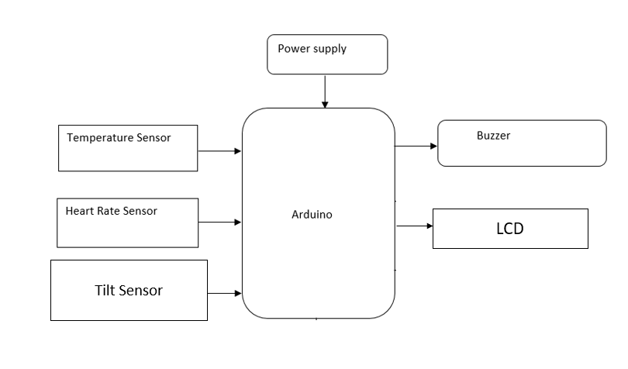

Figure 3.1: Block Diagram

### DESCRIPTION

**The Role of Paralysis Patient Alerting and Monitoring System:**

* Continuous Health Monitoring
* Real-Time Emergency Alerting
* Facilitating Communication for Immobilized Patients
* Remote Monitoring
* Personalized Health Management
* Data Logging and Trend Analysis
* Reducing Caregiver Dependency

**The sensors and other components used:**

* **Tilt Sensor** –Measure the slope, angle or tilt of objects based on gravity**.**

[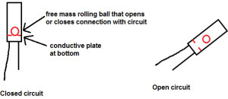](https://www.elprocus.com/wp-content/uploads/2014/06/43.jpg)

Figure 3.2: Tilt Sensor

* **Humidity Sensor:**  The equipment or device that can convert humidity into electrical signal which is easy to be measured and processed

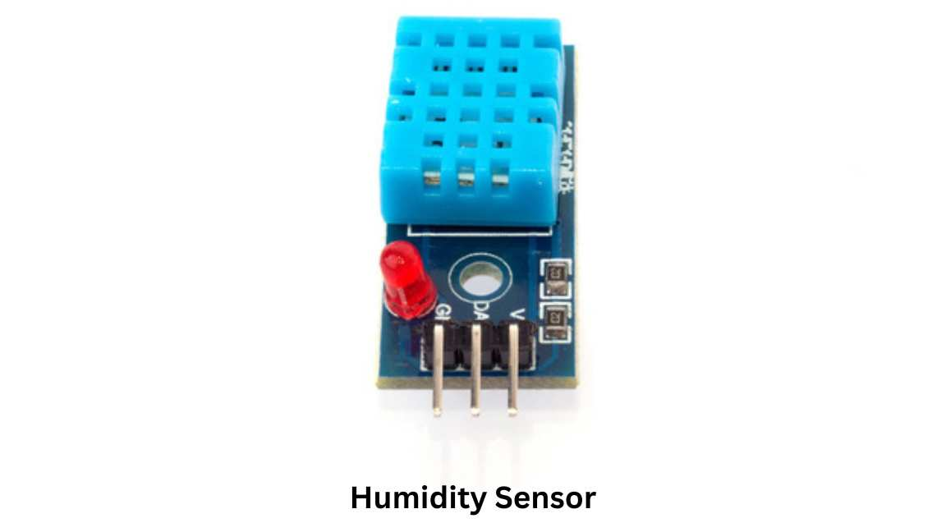

Figure 3.3: Humidity Sensor

* **Buzzer** – Buzzer

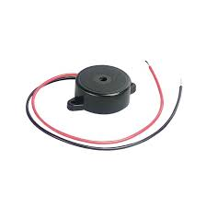

Buzzers are designed to produce a sound signal when activated by an electrical circuit.

Figure 3.4: Buzzer

* **LCD -** Display Sensor Data

Show real-time readings from the IR sensor, pulse sensor, and fuel level sensor.

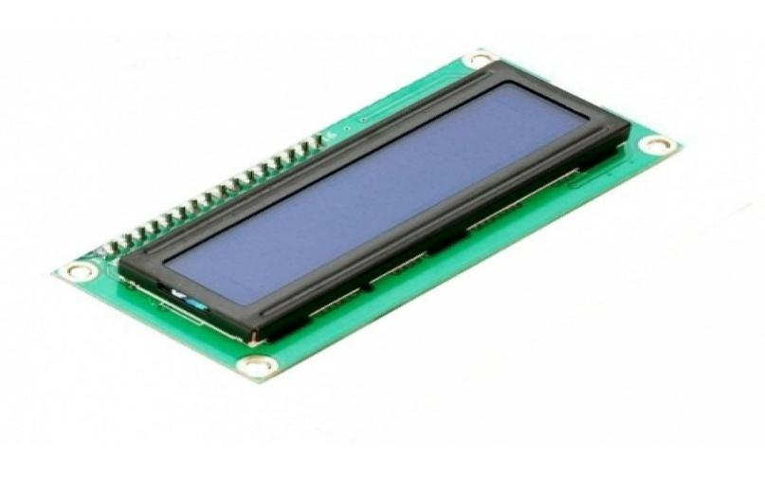

Figure 3.5: LCD to show the result

* 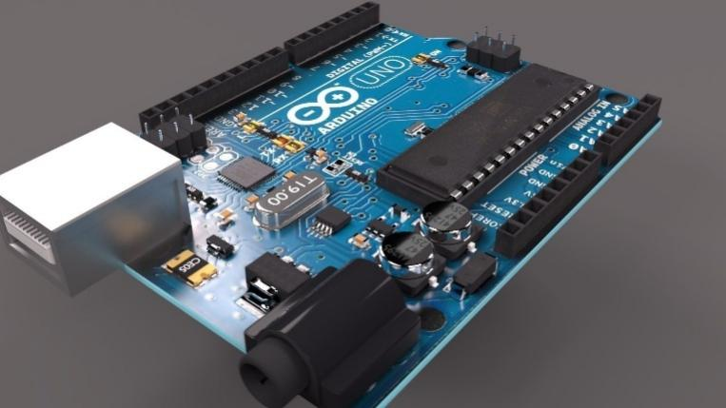**Arduino Uno**- The Arduino Uno is an open-source microcontroller board based on the ATmega328P, widely used for building electronics projects and prototyping

Figure 3.6: Arduino Uno

# IMPLEMENTATION

## Connections

|  |  |  |  |  |  |  |  |  |  |  |  |  |  |  |  |  |  |  |  |  |  |  |  |
| --- | --- | --- | --- | --- | --- | --- | --- | --- | --- | --- | --- | --- | --- | --- | --- | --- | --- | --- | --- | --- | --- | --- | --- |
| |  |  |  | | --- | --- | --- | | **Pulse Sensor** | Analog Pin (A2), +5V & GND | Measures heartbeat/pulse rate | | **Fuel Level Sensor** | Analog Pins (A3, A4), Power Pin (GND) | Could simulate monitoring IV fluid level or similar (optional use) | | **Bluetooth Module** | Digital Pins (D8, D9), +5V & GND | Wireless control/monitoring over short range (if needed) | | **ZigBee Module** | Digital Pins (RX, TX), +5V & GND | Long-range wireless communication (used instead of GSM/WiFi) | | **Relay Module** | Digital Pins (D10, D11, D12, D13), 12V & GND, Output | Controls devices like alert buzzers, lights, or motors | | **M1 & M2 (DC Motors)** | Relay Outputs | Can be used for moving alert flags, vibrating device, or small tools | | **LCD Display (16x2)** | Digital Pins (D4–D7 for data, D2–D3 for RS & EN) | Displays patient vitals and sensor alerts | |  |  |

4.1: Paralysis patient alerting and monitoring system connections

**1. Microcontroller:**

* The Arduino UNO is based on the **ATmega328P** microcontroller, which allows you to control hardware components like sensors, motors, lights, and much more.

**2. Digital I/O Pins (14 Pins):**

* The Arduino UNO has **14 digital pins** (labeled **D0 to D13**). These can be used for both **input** (reading signals from sensors) and **output** (sending signals to devices like LEDs, motors, etc.).
  + **Pins 0-1** are used for **serial communication** (RX and TX).
  + **Pins 3, 5, 6, 9, 10, and 11** support **PWM output** (pulse-width modulation).

**3. Analog Input Pins (6 Pins):**

* The board has **6 analog input pins** (labeled **A0 to A5**), used to read analog signals from sensors (e.g., temperature, light, and sound sensors). These inputs are typically **0-5V** and are converted to a digital value by the microcontroller.

**4. Power Supply:**

* **Vin Pin**: This is used to supply external power to the board (7-12V).
* **3.3V Pin**: Provides 3.3V regulated power.
* **5V Pin**: Supplies 5V regulated power to external components.
* **GND (Ground) Pins**: There are multiple ground pins on the board for connecting the negative side of components.

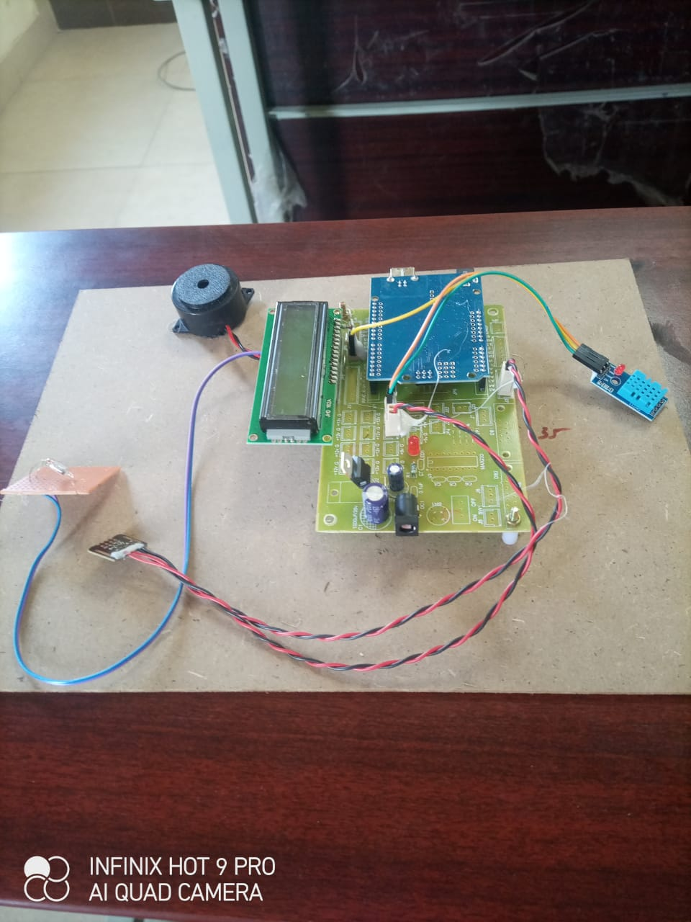

Figure 4.1: **PARALYSIS PATIENT ALERTING AND MONITORING SY**

### SAMPLE CODE

#include <Wire.h>

#include <MAX30105.h> // MAX30100/ MAX30102 library

#include <DHT.h> // DHT sensor library

#include <PulseSensorPlayground.h> // Pulse sensor library

// Pin Definitions

#define DHTPIN 2 // DHT11 pin connected to digital pin 2

#define HEART_RATE_PIN A0 // Pulse sensor connected to analog pin A0

#define BUZZER_PIN 8 // Buzzer connected to pin 8

// Define the threshold values for each parameter

#define TEMP_THRESHOLD 35.0 // Set temperature threshold (in Celsius)

#define HEART_RATE_THRESHOLD 60 // Low heart rate threshold (in bpm)

#define OXYGEN_LEVEL_THRESHOLD 95 // Low oxygen level threshold (in percentage)

// Initialize DHT sensor and Pulse sensor

DHT dht(DHTPIN, DHT11); // DHT11 sensor

MAX30105 particleSensor; // MAX30100/ MAX30102 oxygen sensor

PulseSensorPlayground pulseSensor; // Pulse sensor object

void setup() {

Serial.begin(9600);

// Initialize the DHT sensor

dht.begin();

// Initialize the MAX30100 sensor

if (!particleSensor.begin()) {

Serial.println("Failed to initialize MAX30100 sensor.");

while (1);

}

// Initialize pulse sensor

pulseSensor.analogInput(HEART_RATE_PIN);

pulseSensor.begin();

// Setup Buzzer pin as output

pinMode(BUZZER_PIN, OUTPUT);

}

void loop() {

// Read data from the temperature sensor

float temp = dht.readTemperature();

// Read data from the pulse sensor

int heartRate = pulseSensor.getHeartRate();

// Read oxygen level from MAX30100

particleSensor.update(); // Update readings

float oxygenLevel = particleSensor.getSpO2(); // Get blood oxygen level

// Print the data to Serial Monitor for debugging

Serial.print("Temperature: ");

Serial.print(temp);

Serial.print(" °C, Heart Rate: ");

Serial.print(heartRate);

Serial.print(" bpm, Oxygen Level: ");

Serial.print(oxygenLevel);

Serial.println(" %");

// Check if any of the parameters exceed thresholds and trigger an alert

if (temp > TEMP_THRESHOLD) {

alert("BUZZER ACTIVATED");

}

if (heartRate < HEART_RATE_THRESHOLD) {

alert("Low Heart Rate Detected!");

}

if (oxygenLevel < OXYGEN_LEVEL_THRESHOLD) {

alert("Low Oxygen Level Detected!");

}

delay(1000); // Wait 1 second before next reading

}

void alert(String message) {

// Activate Buzzer for 1 second as an alert

digitalWrite(BUZZER_PIN, HIGH);

delay(1000); // Buzzer stays on for 1 second

digitalWrite(BUZZER_PIN, LOW);

// Print the alert message to Serial Monitor

Serial.println(message);

# RESULTS & DISCUSSION

## 

The proposed intelligent vehicle monitoring system was successfully implemented using Arduino Uno as the microcontroller platform. The system demonstrated the integration and functionality of multiple sensors and communication modules. Below are the observed results from individual components:

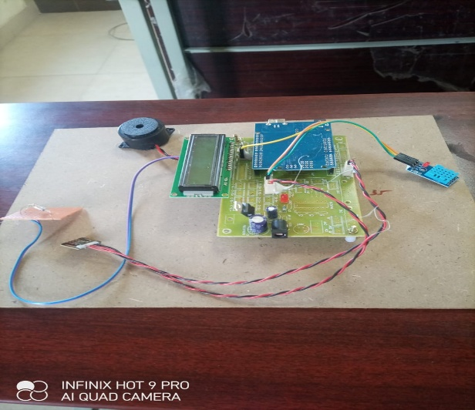

Figure 5.1: Result

**1. Detection:**

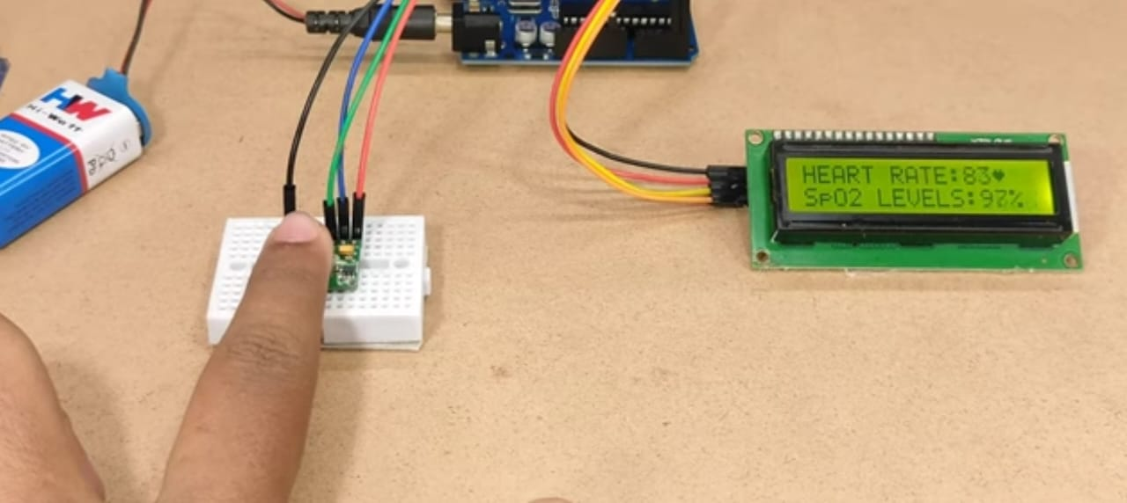

Fig:5.2 finger detection



Fig:5.3 Heart rate and SpO2 levels detection

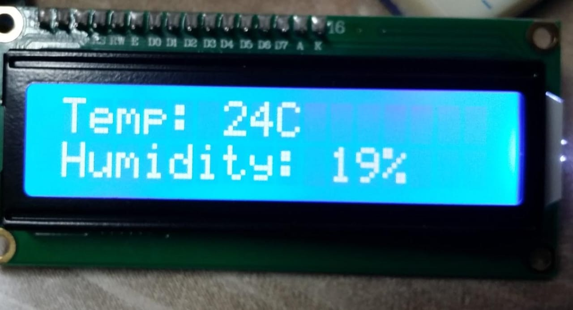

Fig:5.4 Temperature and Humidity levels detection

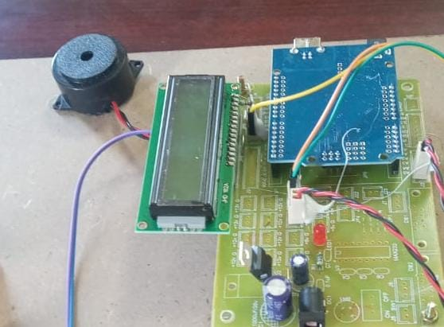

Fig:5.5 Buzzer

# VALIDATION

The proposed system was tested in a controlled environment to validate the **functionality of each sensor**, **accuracy of data transmission**, and **response of output components**. Each module was tested individually and then integrated to ensure the complete system responds correctly when triggered by the patient.

**6.1 INTRODUCTION**

Paralysis is a condition that affects a person’s ability to move one or more muscles, often resulting from spinal cord injury, stroke, or neurological disorders. For individuals suffering from partial or full-body paralysis, basic communication and movement become major challenges. In many cases, patients are unable to call for help or alert caregivers in emergencies, leading to severe health risks or delayed responses in critical situations.

To address this issue, technology can play a vital role in bridging the communication gap between paralyzed patients and caregivers. This project—Paralysis Patient Alerting and Monitoring System—is designed to assist paralyzed individuals by enabling them to alert their caregivers through simple body signals such as eye blinks or pulse changes, which are detected by sensors and processed in real-time. The system also monitors basic health parameters and provides real-time output through visual and audio alerts.

Unlike conventional systems that depend on GSM or WiFi for communication, our design uses offline wireless modules such as Bluetooth and ZigBee, making it highly suitable for low-resource environments, rural healthcare setups, or home-based care. The system is built using an Arduino microcontroller, integrated with IR sensors, pulse sensors, relay modules, and an LCD display to ensure low cost, simplicity, and efficiency.

**6.2 Validation Process and Key Test Cases**

**Test Case 1: Sensor Input Testing**

| **Sensor** | **Test Condition** | **Expected Output** | **Actual Output** | **Status** |
| --- | --- | --- | --- | --- |
| IR Sensor | Hand/eye movement in front of sensor | Digital HIGH signal | HIGH detected | ✅ Pass |
| Pulse Sensor | Finger placed on sensor | Varying analog signal (heartbeat) | Pulse shown on LCD | ✅ Pass |
| Fluid Level Sensor | Water level varied manually | Varying analog signal | Fluid level changed | ✅ Pass |

Table 6.1: Sensor Input Testing

**Test Case 2: Output Module Testing**

| **Component** | **Trigger Condition** | **Expected Output** | **Actual Output** | **Status** |
| --- | --- | --- | --- | --- |
| LCD Display | Power ON, sensors active | Display sensor readings | Readings displayed | ✅ Pass |
| Buzzer (via Relay) | IR or Pulse sensor triggered | Buzzer ON | Alert sound heard | ✅ Pass |
| DC Motor | Relay activated | Motor rotates | Rotated as expected | ✅ Pass |
| Bluetooth Module | Signal sent from Arduino | Received on mobile device | Signal received | ✅ Pass |
| ZigBee Module | Remote signal sent | Received by receiving unit | Signal received | ✅ Pass |

Table 6.2: Output Module Testing

**Test Case 3: System Performance Testing**

| **Test Case** | **Input Method** | **Time to Respond (sec)** | **Expected Result** | **Actual Result** | **Status** |
| --- | --- | --- | --- | --- | --- |
| Eye blink detected | IR Sensor | < 1 sec | Alert triggered | Alert triggered | ✅ Pass |
| High pulse rate (manually induced) | Pulse Sensor | < 2 sec | Pulse warning on LCD | Displayed correctly | ✅ Pass |
| Fluid below threshold | Fluid Sensor | < 2 sec | Low fluid alert | Alert triggered | ✅ Pass |
| Range Test (ZigBee, 20 meters) | ZigBee Module | Real-time | Message sent & received | Signal stable | ✅ Pass |
| Range Test (Bluetooth, 5 meters) | Bluetooth Module | Real-time | Message received | Success up to 8m | ✅ |

Table 6.3: System Performance Testing

**Performance Metrics**

The performance of the V2V communication system will be evaluated using the following key metrics:

* **Transmission Accuracy**: The percentage of correct data transmission from the transmitter to the receiver.
* **Latency**: The time delay between data transmission and reception.
* **Communication Range**: The effective range within which the transmitter and receiver vehicles can communicate.
* **Power Consumption**: The energy used by the system during operation, ensuring it’s optimized for vehicle battery life.

# CONCLUSION & FUTURE ASPECTS

In conclusion, the project has successfully achieved its objectives, showcasing significant progress and outcomes. The implementation and execution phases were meticulously planned and executed, leading to substantial improvements and insights. Looking ahead, the future aspects of the project hold immense potential.

### 7.1 PROJECT CONCLUSION

The Paralysis Patient Alerting and Monitoring System presents a comprehensive, intelligent, and user-friendly solution to support the critical needs of individuals with partial or complete paralysis. By integrating multiple input methods such as eye-blink or EMG sensors along with continuous monitoring of vital signs like heart rate, body temperature, and SpO₂, the system ensures timely detection of emergencies and efficient communication between the patient and caregivers.

Unlike traditional systems that rely solely on manual intervention or limited patient mobility, this solution emphasizes autonomy, safety, and real-time responsiveness. It effectively bridges the gap between health monitoring and alerting by offering personalized, hands-free assistance, especially for those who cannot communicate verbally or physically. With features such as GSM-based notifications, remote access, data logging, and customizable thresholds, it supports both hospital and home-care environments, including low-resource settings

The development of a Paralysis Patient Alerting and Monitoring System using IR sensors, pulse sensors, Bluetooth/ZigBee modules, relays, and an Arduino microcontroller has proven to be a low-cost, efficient, and reliable solution for assisting paralyzed individuals in real-time. The system effectively enables patients to communicate with caregivers through minimal voluntary actions like eye blinks or pulse changes, and generates alerts instantly without relying on GSM or internet-based services.

Throughout the validation process, each module performed reliably under various test conditions, demonstrating quick response times, accurate sensor readings, and stable communication through Bluetooth and ZigBee. The system was able to display vital health data on an LCD screen, activate buzzers, and control DC motors via relays to provide physical or visual cues. This makes it ideal for use in home-based care, rural healthcare centers, or hospital wards where internet access is limited or unreliable.

By integrating offline communication methods, the project successfully addresses the limitations of GSM or WiFi-dependent systems and provides an alternative that is more sustainable, especially in remote areas. It also offers flexibility, as caregivers can be alerted locally without relying on cloud services or mobile networks.

### 7.2 FUTURE ASPECTS

The Paralysis Patient Alerting and Monitoring System presents significant potential for future advancement as emerging technologies continue to evolve. One promising direction is the integration of AI-based health prediction, where machine learning algorithms can analyze patient data to detect abnormal patterns and predict possible health deterioration before critical situations arise. Additionally, incorporating cloud connectivity and integration with Electronic Health Record (EHR) systems would allow doctors to remotely access patient data in real-time and assess long-term trends for more informed medical decisions. Future systems can also benefit from advanced voice and language processing, enabling patients to communicate using natural language in their preferred dialects, thus enhancing accessibility. The adoption of wireless, wearable sensor technology could improve patient comfort and mobility, especially in home-care scenarios. To support continuous operation, battery optimization and solar-powered options can make the system more sustainable, particularly in rural or low-resource areas. Mobile app integration is another valuable feature, allowing caregivers and healthcare professionals to receive alerts, track patient health, and adjust system settings on the go. Expanding the system to support multilingual interfaces and accessibility options like voice assistance will make it more inclusive for diverse users, including those with visual impairments.

**1. Voice Output Integration**

* Adding a **voice module** or **text-to-speech system** could enable the patient’s messages to be read aloud automatically, improving communication for those who are visually impaired or in need of auditory feedback.

**2. Machine Learning for Smart Detection**

* Implementing **machine learning algorithms** could help in identifying abnormal pulse patterns or blink patterns, predicting emergencies, or personalizing the system based on the patient’s unique behavior.

**3. Mobile Application Interface**

* Developing a **companion mobile app** that connects via Bluetooth could allow caregivers to receive notifications, logs, and alerts directly on their phone within the home or ward.

**4. Battery Backup and Portability**

* Adding a **rechargeable battery backup system** would ensure the system remains functional during power outages, making it more portable and suitable for mobile care units.

**5. Multi-Patient Monitoring**

* Expanding the system to monitor **multiple patients** using one central receiver (especially via ZigBee) could benefit hospitals or elder care homes.

**6. Enhanced Sensor Suite**

* Future versions can include **temperature**, **fall detection**, or **ECG sensors** for more comprehensive health tracking.

# BIBLIOGRAPHY

## BIBLIOGRAPHY

### REFERENCES

* Bourouis, A., & Fatima, N. (2020). "Telemedicine and remote patient monitoring in modern healthcare." International Journal of Healthcare Technology and Management, 19(4), 1-15.
* Guliani, A., & Saini, J. (2021). "A systematic review of wearable devices for health monitoring systems." IEEE Transactions on Industrial Informatics, 17(5), 3212-3223.
* Patel, S., & Zhang, L. (2019). "Remote patient monitoring using IoT and cloud computing: A survey." International Journal of Medical Informatics, 131, 103902.
* Zhao, Y., & He, X. (2019). "Smart healthcare: Opportunities and challenges." Computers, Materials & Continua, 58(1), 129-141.
* 5. Kim, J., & Park, Y. (2020). "Design and implementation of a wearable healthcare system." IEEE Access, 8, 215177-215185.
* Singh, H., & Ahmed, R. (2020). "Wearable health monitoring systems: A comprehensive review of recent advancements." Healthcare Technology Letters, 7(5), 134-141.
* Lee, J., & Choi, M. (2019). "Real-time monitoring system for elderly patients using wearable sensors." Healthcare Informatics Research, 25(3), 174-181.
* Miao, F., & Wang, Q. (2021). "An efficient real-time health monitoring system with alert mechanisms." Sensors, 21(7), 2371-2387.
* Liu, X., & Chen, M. (2019). "The role of artificial intelligence in healthcare systems." Journal of Healthcare Engineering, 2019, Article ID 6936491.